**Dajngo Views**

**------------------**

1. **Create new records using CreateAPIView and APIView**

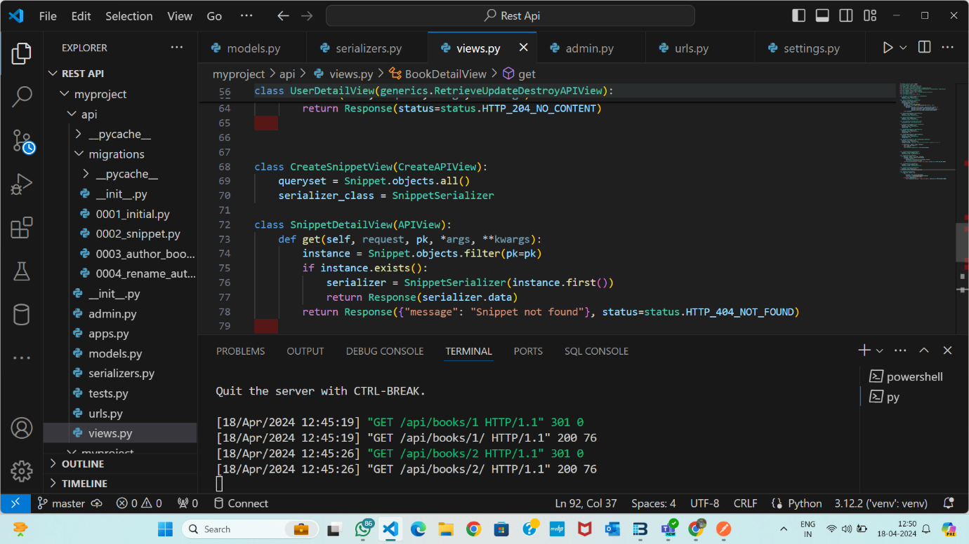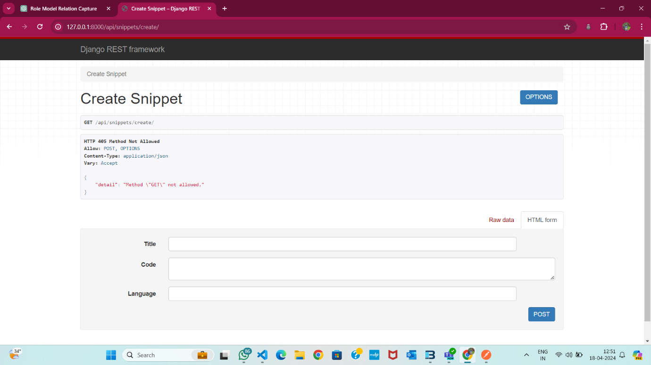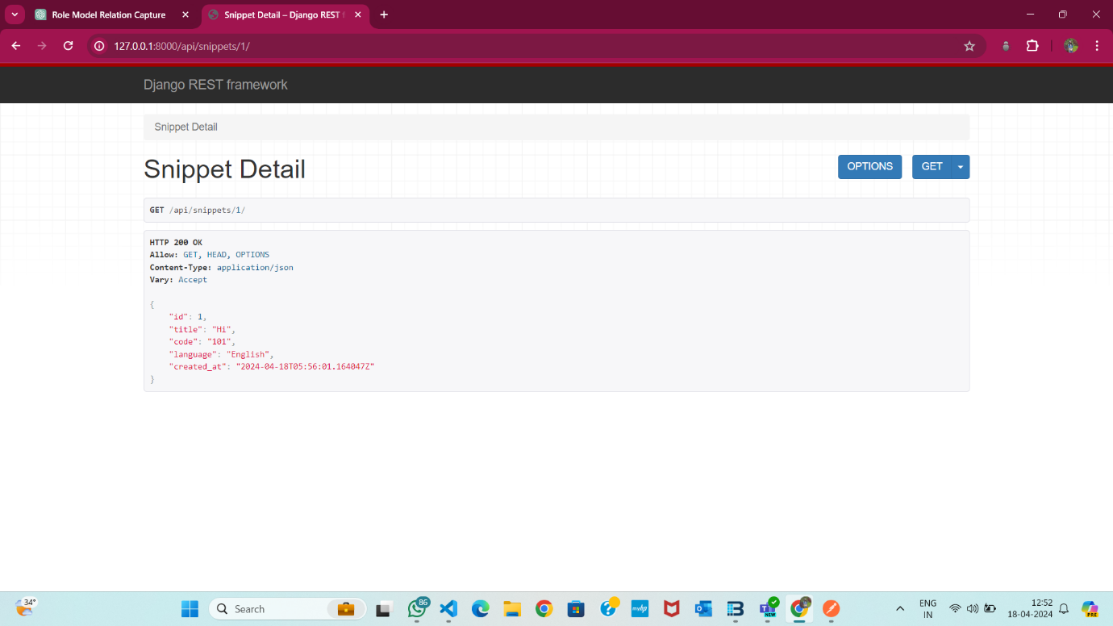**2. Retrieve record details using RetrieveAPIView and APIView, considering foreign key fields.**

